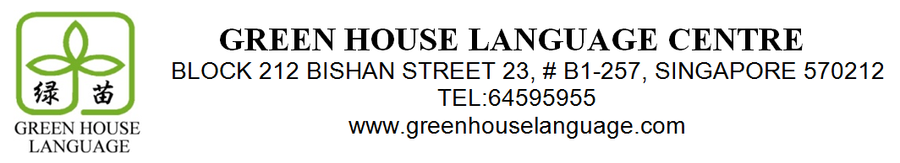

Dear Parents,
As the year draws to a close and with the PSLE looming next year, we will be opening special preparatory Holiday Chinese and English Enrichment Classes for next year’s exams. These classes will specifically target the most challenging aspects of the exams, focusing on essays, comprehension, and oral skills. They will highlight key techniques and methods to best grapple with the difficulties the PSLE poses.
Both the English and Chinese holiday classes will consist of five 2-hour lessons, as set out below. Should your child be unable to attend any of the lessons, we will endeavour to offer a replacement. As places are limited, we are opening registration first to existing students, at a preferential rate of $220 for either Chinese or English classes, and $400 for both. Please complete this form and submit it, with payment by cash or cheque (payable to ‘Green House Language Centre’), by Nov 5 to register.
Chinese | Date and Time
Lesson 1 | 27th November, Monday, 9:30am – 11:30am
Lesson 2 | 28th November, Tuesday, 9:30am – 11:30am
Lesson 3 | 29th November, Wednesday, 9:30am – 11:30am
Lesson 4 | 30th November ,Thursday, 9:30am – 11:30am
Lesson 5 | 1st December, Friday , 9:30am – 11:30am
English | Date and Time
Lesson 1 | 27th November, Monday, 11:30am – 1:30pm
Lesson 2 | 28th November, Tuesday, 11:30am – 1:30pm
Lesson 3 | 29th November, Wednesday 11:30am – 1:30pm
Lesson 4 | 30th November ,Thursday, 11:30am – 1:30pm
Lesson 5 | 1st December, Friday, 11:30am – 1:30pm

Name of Student: ______________________ (Chinese) _________________________ (English)
Courses: Both/English Only/Chinese Only* Cheque No./Cash: ______________ Bank: __________

Dear Parents,
As the year draws to a close and with the PSLE looming next year, we will be opening special preparatory Holiday Chinese and English Enrichment Classes for next year’s exams. These classes will specifically target the most challenging aspects of the exams, focusing on essays, comprehension, and oral skills. They will highlight key techniques and methods to best grapple with the difficulties the PSLE poses.
Both the English and Chinese holiday classes will consist of five 2-hour lessons, as set out below. Should your child be unable to attend any of the lessons, we will endeavour to offer a replacement. As places are limited, we are opening registration first to existing students, at a preferential rate of $220 for either Chinese or English classes, and $400 for both. Please complete this form and submit it, with payment by cash or cheque (payable to ‘Green House Language Centre’), by Nov 5 to register.
Chinese | Date and Time
Lesson 1 | 27th November, Monday, 9:30am – 11:30am
Lesson 2 | 28th November, Tuesday, 9:30am – 11:30am
Lesson 3 | 29th November, Wednesday, 9:30am – 11:30am
Lesson 4 | 30th November ,Thursday, 9:30am – 11:30am
Lesson 5 | 1st December, Friday , 9:30am – 11:30am
English | Date and Time
Lesson 1 | 27th November, Monday, 11:30am – 1:30pm
Lesson 2 | 28th November, Tuesday, 11:30am – 1:30pm
Lesson 3 | 29th November, Wednesday 11:30am – 1:30pm
Lesson 4 | 30th November ,Thursday, 11:30am – 1:30pm
Lesson 5 | 1st December, Friday, 11:30am – 1:30pm

Name of Student: ______________________ (Chinese) _________________________ (English)
Courses: Both/English Only/Chinese Only* Cheque No./Cash: ______________ Bank: __________

